**OMSB**

**Sultanate of Oman**

**Imtac LLC**

PO Box 196, PC 116, Mina-al-Fahal,

Muscat, Sultanate of Oman



Tables 1

Glossary 1

Team Members 2

1 Document Overview 3

1.1 Introduction 3

1.2 To Be Document 3

1.3 Target Audience 3

1.4 Actors in the module 4

1.5 Assumptions & Pre-requisites 5

2 BRD 5

2.1 Link to the BRD document 5

2.2 Additional BRD notes 5

3 Prototype 5

3.1 UX Link 5

4 ARS – Final Selection. 5

4.1 Objective of the module 5

4.2 Flow Diagram for ARS Final Selection 5

4.2.1 Screens 6

4.2.2 Business Logic 6

4.2.3 Notifications & Email template 27

5 Liferay Design Components 28

6 ER Diagram 29

7 Appendix A: Document Control 29

7.1 Revision History 29

Tables

Table 1: Glossary of terms 4

Table 2: Team members 4

Table 3: Target audience 5

Table 4: Description of actors 5

Glossary

|  |  |
| --- | --- |
| **Term** | **Description** |
|  |  |
|  |  |
|  |  |
|  |  |
|  |  |
|  |  |

Table 1: Glossary of terms

Team Members

|  |  |
| --- | --- |
| **Name** | **Role** |
| **Ravi Shah** | Tech Lead |
| **Jinal Patel** | Dev Lead |
| **Himanshu Nimavat** | Sr. Dev |
| **Niddhi Thacker** | Sr. Dev |
| **Taher Mahmood** | Sr. Dev |
| **Mathew** | Business Analyst |
| **Jayabalan T.** | Project Manager |
| **Hardik Vyas** | Project Manager |
| **Gaurav Gurjar** | Sr. UI Dev |
| **Siddhant Patel** | Sr. UI Dev |
| **Akash Nakod** | Sr. UX Designer |

Table 2: Team members

# Document Overview

## Introduction

The introduction of the Software Requirements Specification (SRS) provides an overview of the entire SRS with purpose, definitions, terms, abbreviations, and overview of the SRS. The aim of this document is to gather, analyse, and give an in-depth insight of the complete MSIC module by defining the problem statement in detail.

Nevertheless, it also concentrates on the capabilities required by stakeholders and their needs while defining high-level product features. The detailed requirements of the MSIC module is provided in this document.

## To Be Document

This Document is aimed to provide a detailed description of the To-Be system, and it will include several diagrams that show a different system aspect. The information of this document is based on the business requirement document that was created by Imtac and approved by the customer.

However, the result of the analysis and design process that is present in this document will enable the implementer to meet the exact customer requirements that appeared in previous document.

The solution requirements will be defined in enough detail to allow them to be constructed.

## Target Audience

|  |  |
| --- | --- |
| **Audience** | **Description** |
| **Technical Team** | This document aims to enable the technical team to understand the requirements to design and build the solution accordingly. |
| **Business Owner** | This document aims to enable the business owner to review the stated requirements as well as the required capabilities to be implemented. |
| **Quality Assurance** | This document aims to enable the QA to write the test cases related to the solution. |

Table 3: Target audience

## Actors in the module

|  |  |
| --- | --- |
| **Actor** | **Description** |
| **ARS Staff** | The ARS staff will play a main role in this process. |
| **EC** | The EC user will schedule interviews and filtration exams. |
| **Media Department** | Create posts for the announcement of the interview schedule details. |
| **EPO** | The EPO user will provide an EB meeting review. |
| **BOT** | The BOT user will provide their review. |
| **Administrative Affairs Section** | Administrative Affairs Section users will update that the ID Cards Status. |
| **IT Department** | The IT Department user issues OMSB email IDs. |
| **E-library** | The MSIC department staff will provide the E-Library access status. |
| **Medical Simulation Centre** | The MSIC department staff will provide the MSC access status. |
| **Purchasing and Contracts Section** | Finance Affairs Department staff will update that lab coat and resident file Status. |
| **Skill Development Section** | The MSIC department staff will provide access to Skill Development workshops during orientation. |
| **Follow-up Health Care**  **Committee (FHC)** | Trainee Affairs Department staff can download the AHA Form. |
| **Trainee Affairs Follow-Up**  **Section (TAFUS)** |  |

Table 4: Description of actors

## Assumptions & Pre-requisites

1. The Developer should follow sonar compliance when writing the code.
2. LDS should have sonar lint installed.
3. For each and every action, render, resource – a separate MVCCommands shall be implemented by the developer.
4. The default render generated by Liferay should not be used.
5. The naming conventions and the coding conventions shall be strictly followed by the Dev team as shared earlier.
6. The notification & email will be configurable using the email-configuration-template developed earlier.
7. RBAC – All the data-tables shall follow the RBAC framework of Liferay and it should be configurable.
8. All the language should go in Liferay’s Language Override module. (Strictly no language in properties file.)
9. Custom Form will be implemented along with jQuery validation.
10. Loader should be shown at all places. If the page load time is high and multiple service calls are happening on the page, better to show loader at render also. Also, for all the Ajax calls loader should appear. In case of cascading dropdowns also, loader should come. This is all for better user experience.
11. Headless approach will be used from coding perspective, so that in future if client demands the service to be consumed inside the mobile app, Web team will be able to make it available with minimal efforts.
12. Proper breadcrumbs should be implemented as per our MSIC flow.
13. Relevant data to be inserted while testing on any servers.
14. The service builder generated entities must have a namespace appended i.e., OMSB_AD.
15. The audit fields should be present for all the database tables.
16. Proper loggers should be used to log the information. Also, wherever needed their only use log.info else put it “log.debug”.

# BRD

## Link to the BRD document

## Additional BRD notes

NA

# Prototype

## UX Link

[[ARS Final Selection](https://www.figma.com/file/VTqljNXDhmiCoAFrxY3Wz0/OMSB-MAIN?type=design&node-id=10933-27498&mode=design)](https://www.figma.com/design/wcJGMTIsQcevAgAOB9O9mv/OMSB-MAIN-(Phase-2)?node-id=14271-36747&node-type=canvas)

# ARS – Final Selection.

## Objective of the module

To outline the screening and selection process for applicants in the Local Fellowship Program, ensuring a structured evaluation, recommendation, and onboarding process involving the employer, ARS user, EC, EPO, and BOT, ultimately leading to the issuance of offer letters and coordination with relevant departments for candidate integration.

## Flow Diagram for ARS Final Selection

|  |  |  |
| --- | --- | --- |
| **Step #** | **User** | **Action Taken** |
| 1 | AR User | The AR user will receive a list of candidates who are employed in the government sector but not in the MOH for decision-making. |
| 2 | DGHS User | The DGHS user will receive a list of candidates who are employed in the government sector and in the MOH for decision-making. |
| 3 | DGHR/DGAA User | The DGAA user will receive a list of candidates that the DGHS approved for decision-making. |
| 3 | ARS User | The ARS user will receive a list of candidates who are unemployed and private sector employees for decision-making. Additionally, the approved candidate list from the DGAA and AR user candidate list will be available here. After the ARS user approves the candidates, the list will be sent to the EC. |
| 4 | EC User | The EC will schedule interviews and filtration exams if required. |
| 5 | Applicant | The applicant can accept or reject the interview scheduled date and time. |
| 6 | Panel member | The panel members will evaluate and provide the scores. |
| 7 | Panel chairman | The panel chairman will review the scores from the panel members, provide his rankings and recommendations, and then send the summary report to the EC. |
| 8 | EC User | The EC user will receive the chairman's summary report, provide his final recommendation, and then send the results to the ARS user. |
| 9 | ARS User | The ARS user will create a consolidated list and send it to the EPO based on the EC review results. |
| 10 | EPO | The EPO will review the list, change the rankings and swap applications between programs, and then return it to the ARS |
| 11 | ARS User | The ARS user will create a consolidated list and send it to the BOT based on the EPO review results. |
| 12 | BOT | The BOT will follow the same process as the EPO. |
| 13 | ARS User | The ARS user will review the results from the BOT. Based on that, they will create a provisional offer letter and send it to the EPO for digital signature. |
| 14 | EPO | The EPO will sign the offer letters, which will then be sent to the applicants. |
| 15 | Applicant | The applicants will receive the offer letter, after which they can either approve or reject it. |
| 16 | ARS User | The ARS user will create a list of candidates whose offer letters have been accepted, officially select them, and then forward the candidates to the appropriate department. |
| 17 | Administrative Affairs Section staff | The staff in the Administrative Affairs Section will update the ID card status. |
| 18 | EPO | The EPO user will request and upload the qarar. |
| 19 | Trainee Affairs Follow-Up  Section staff  (Follow-up Health Care  Committee (FHC)) | Trainee Affairs Follow-Up Section staff can view the candidates' health status and download the information. |
| 20 | IT Department staff | The IT Department staff will create the OMSB email ID and update the status. |
| 21 | Medical Library Section staff  (E-library) | The Medical Library Section staff will update the status of library access. |
| 22 | Simulation Program Section staff  (Medical Simulation Centre) | The Simulation Program Section staff will update the status of MSC. |
| 23 | Purchasing and Contracts Section staff | Purchasing and Contracts Section staff will update the status of lab coat and resident file. |
| 24 | Skill Development Section staff | The Skill Development Section staff will update the status of access to Skill Development workshops. |

### **Screens**

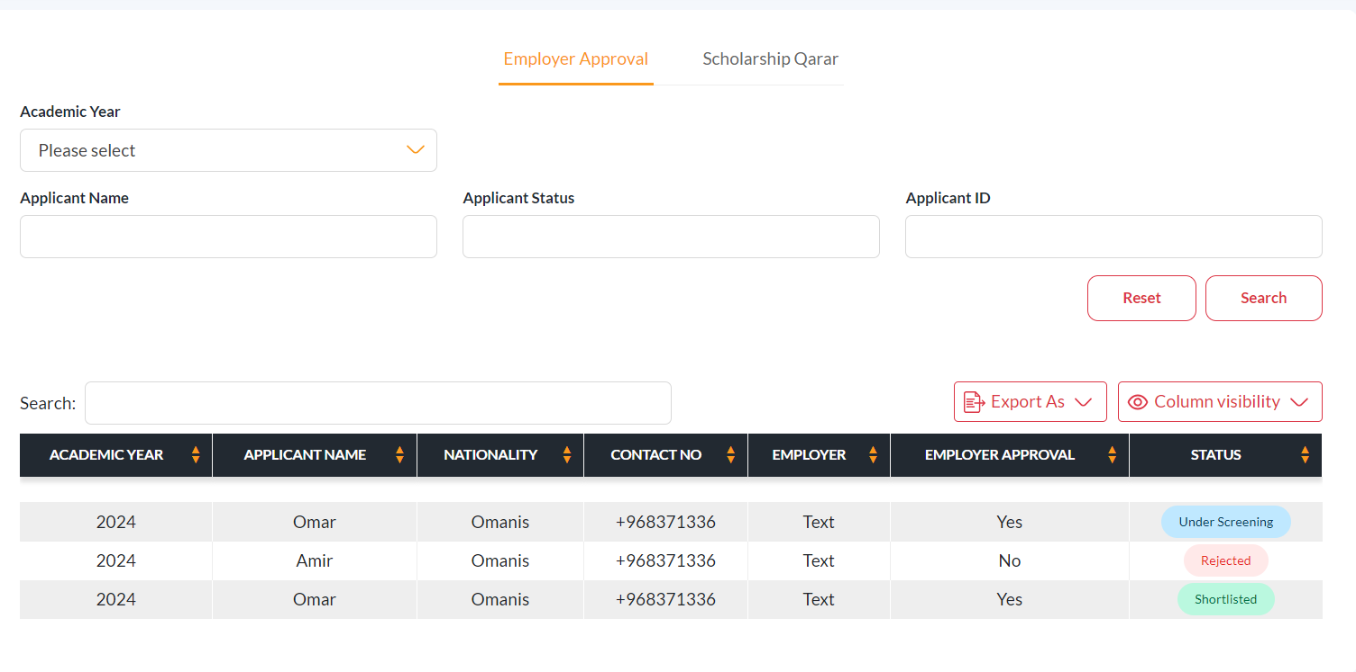

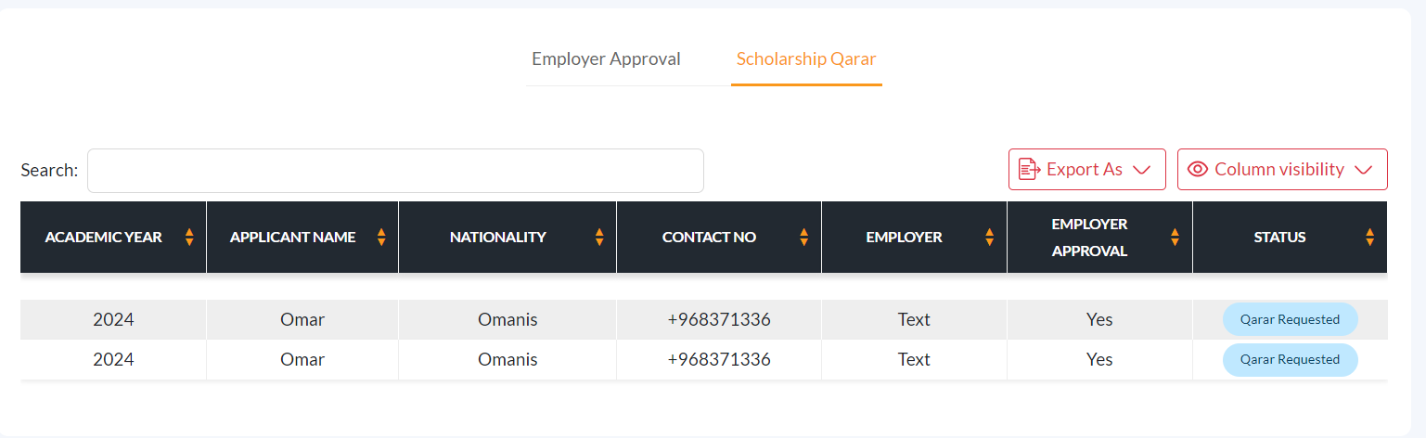

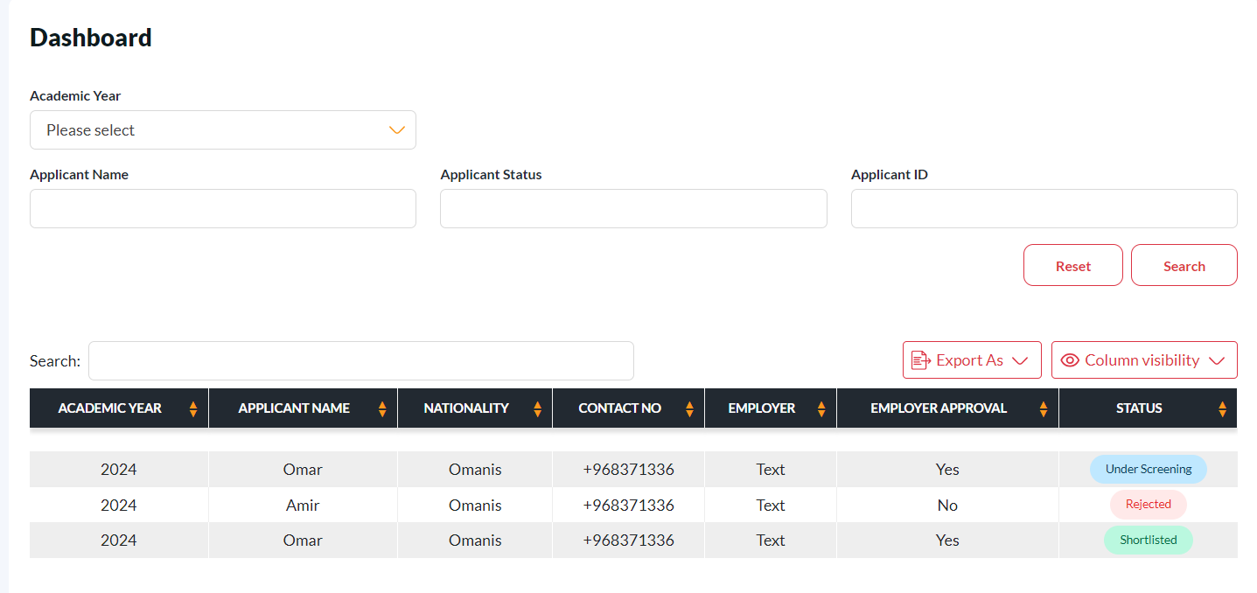

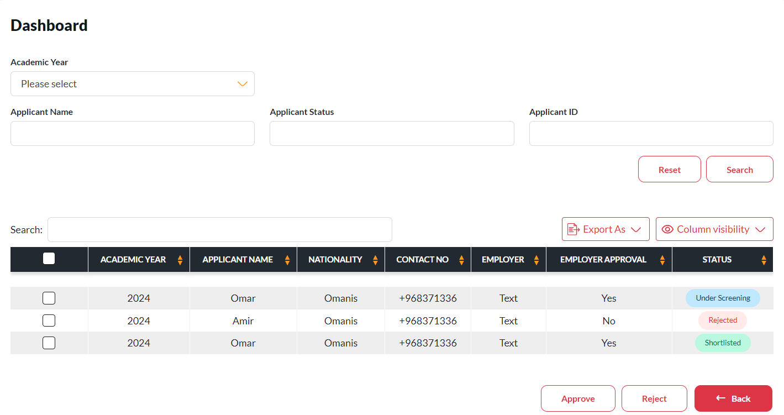

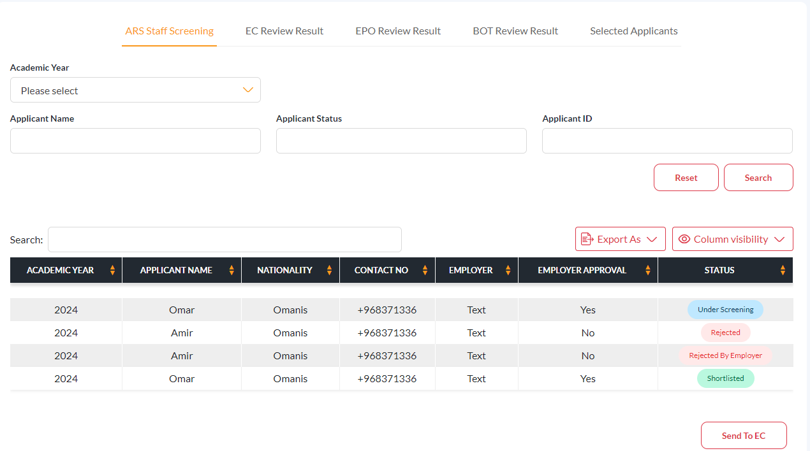

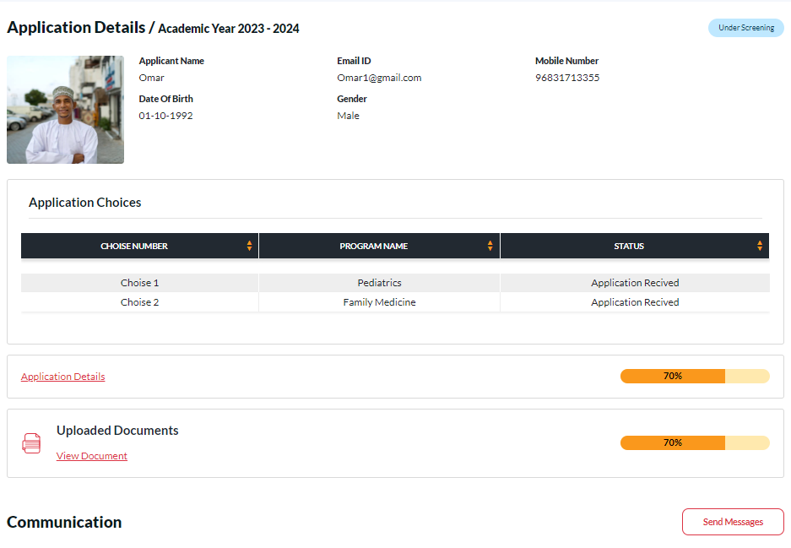

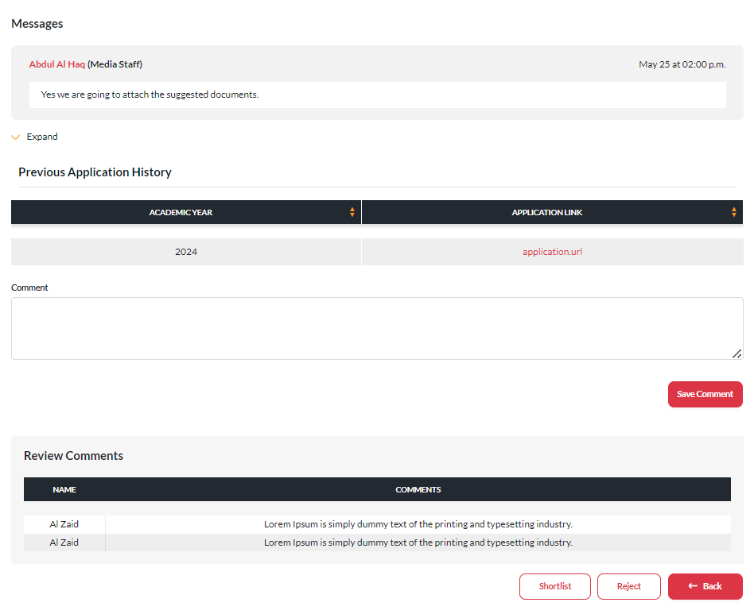

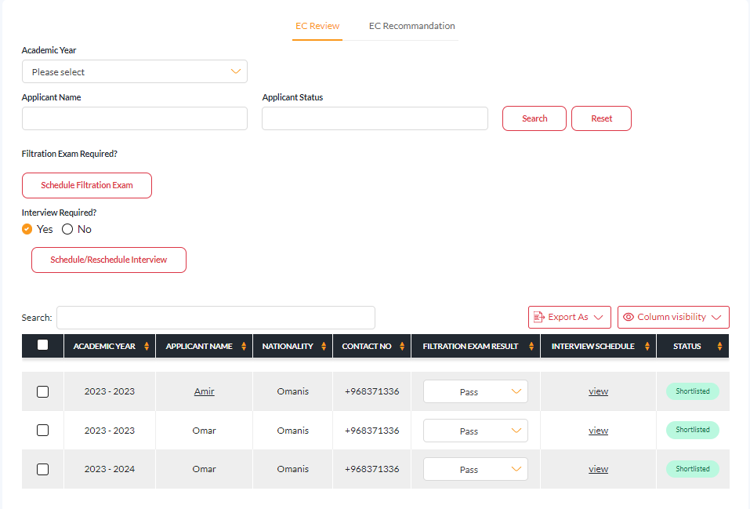

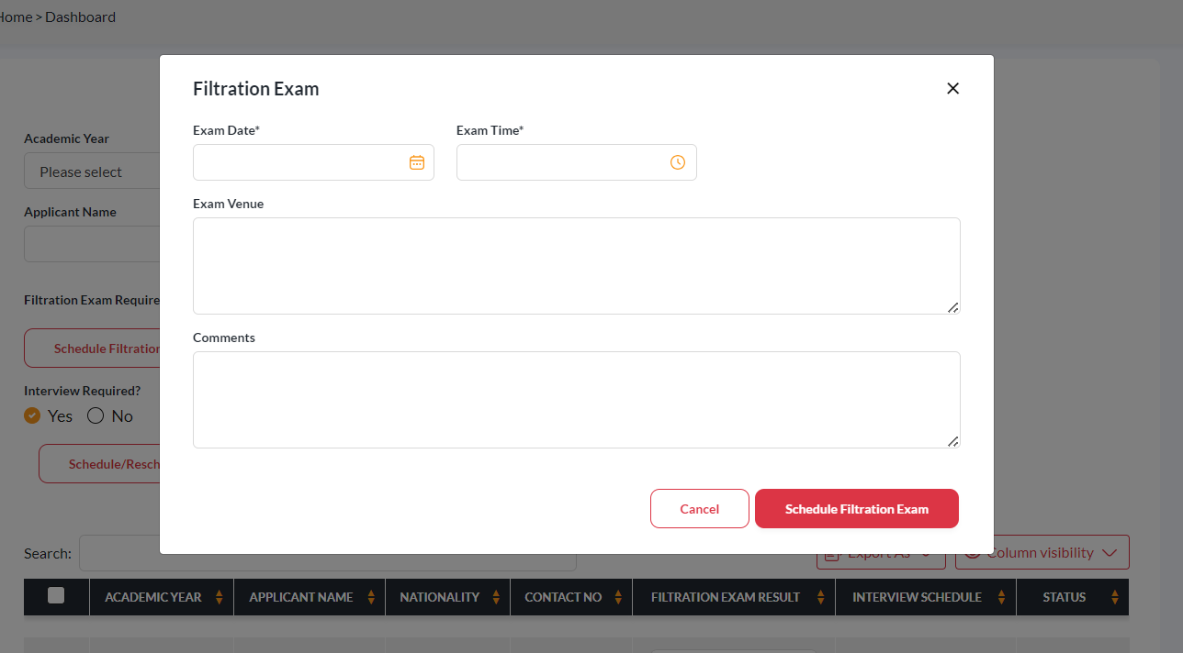

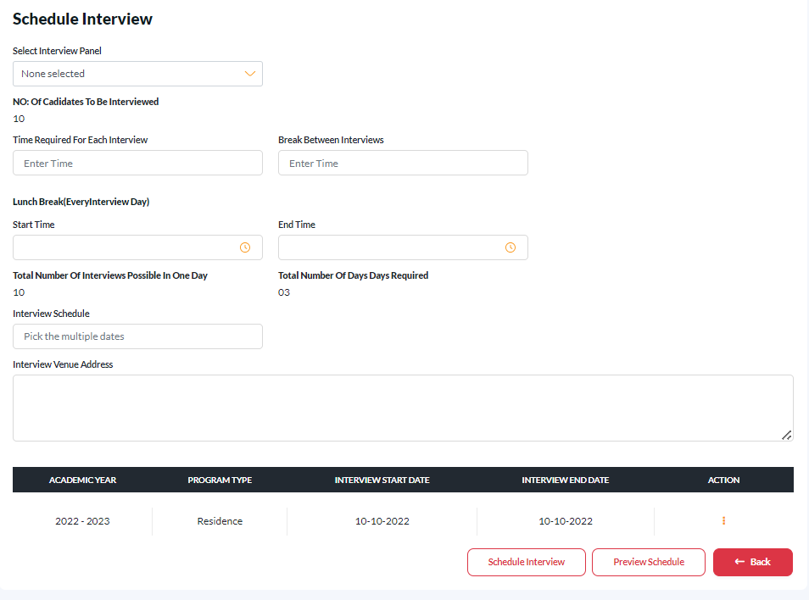

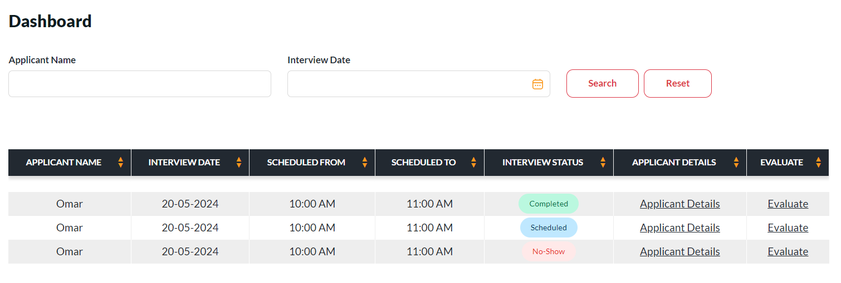

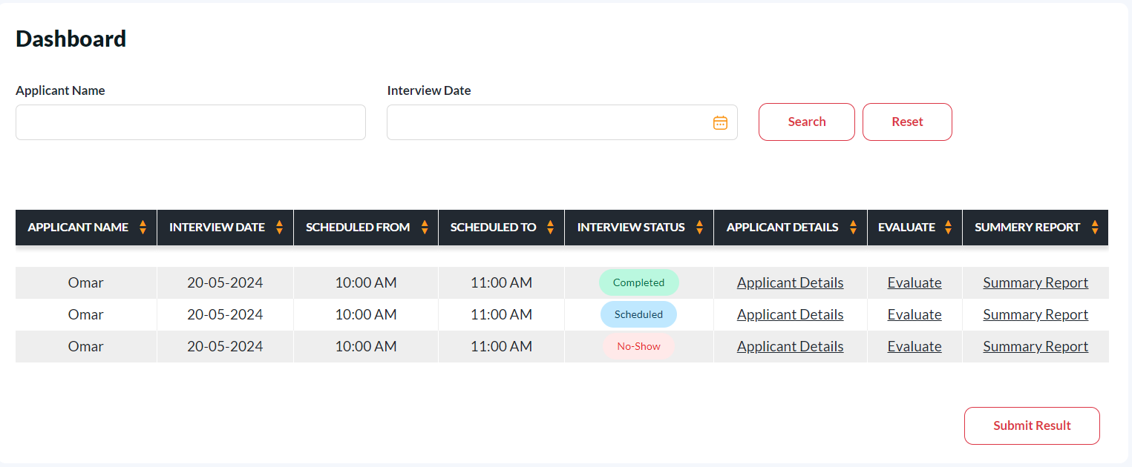

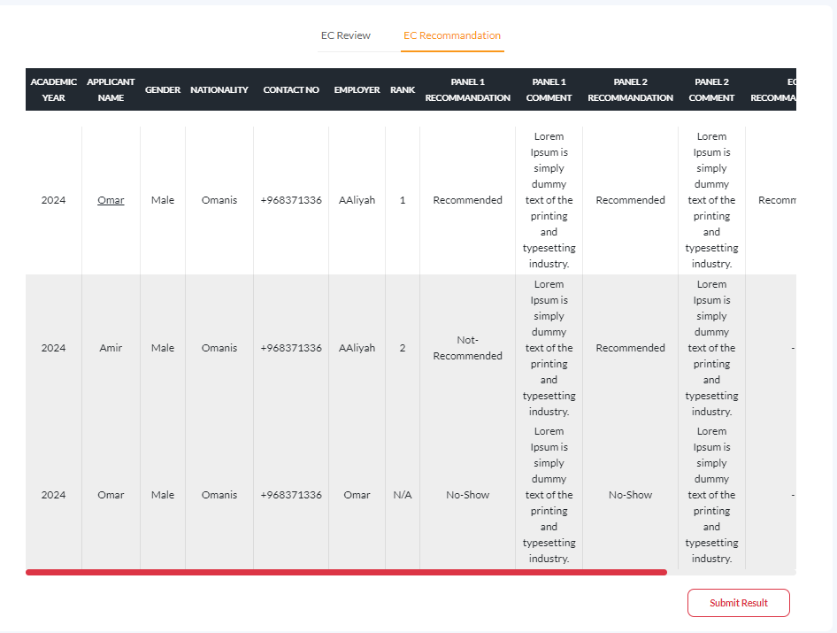

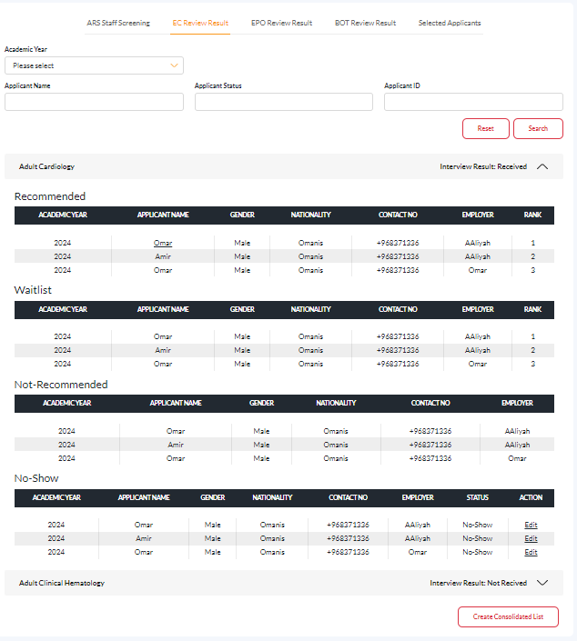

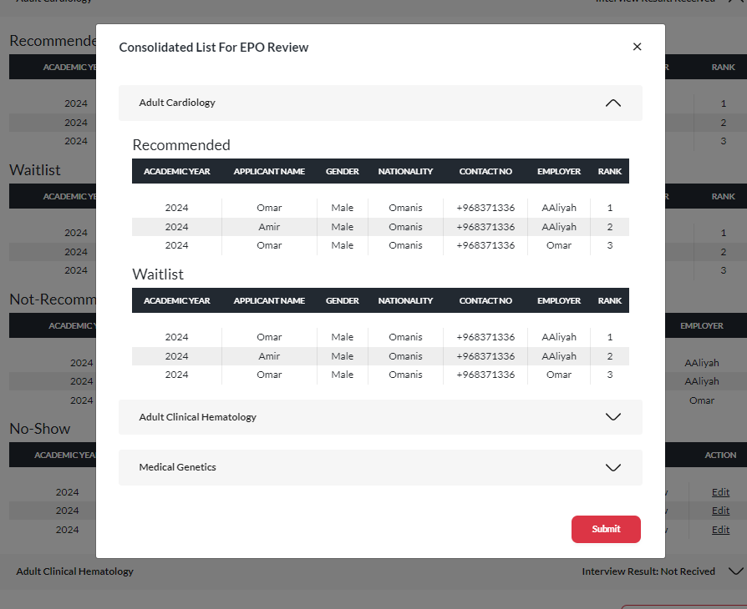

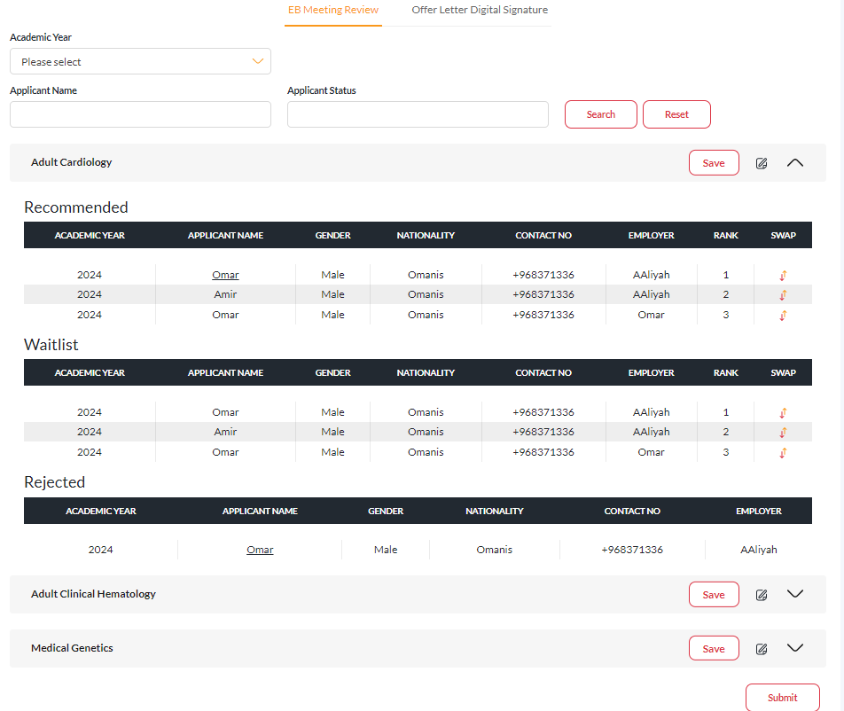

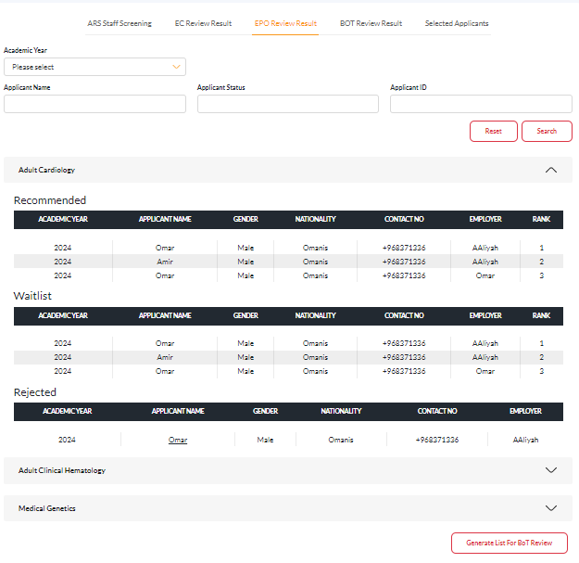

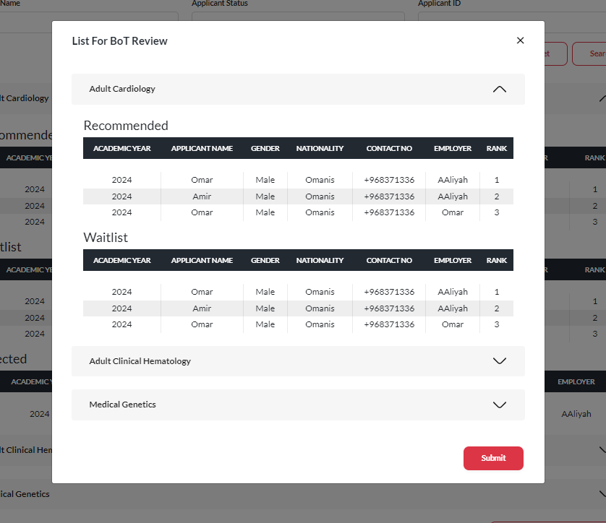

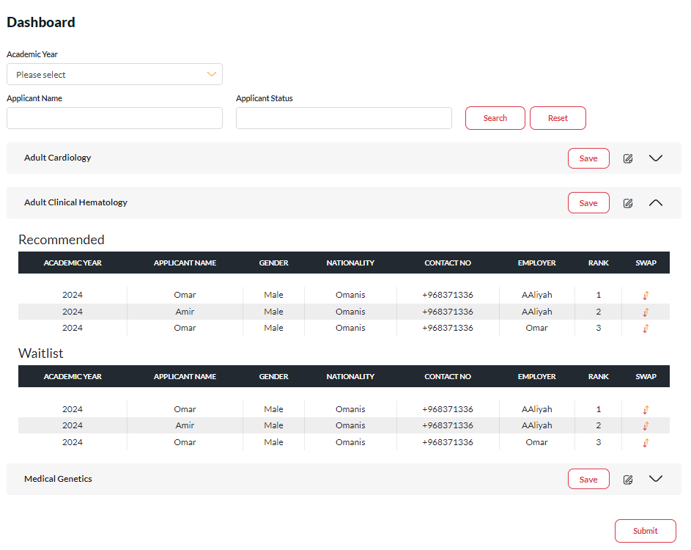

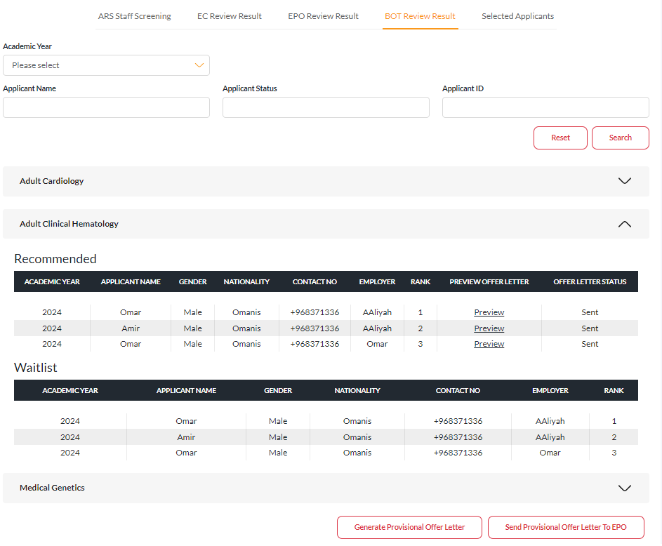

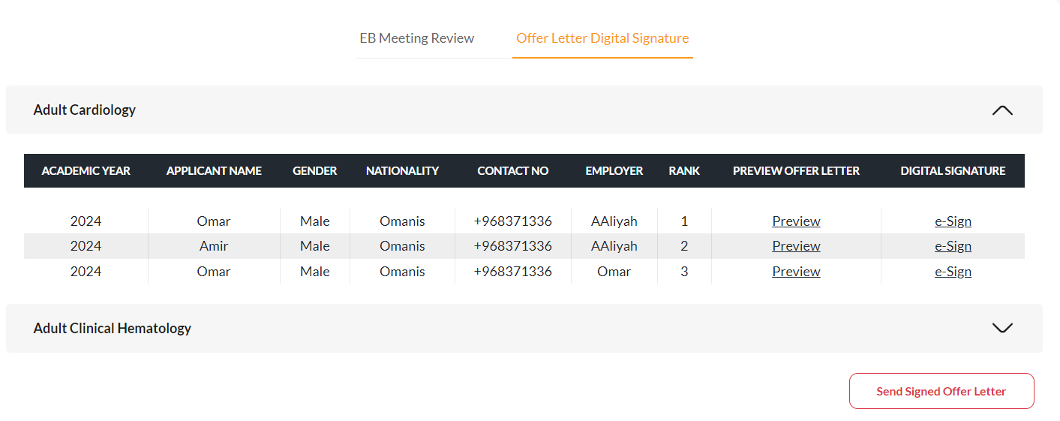

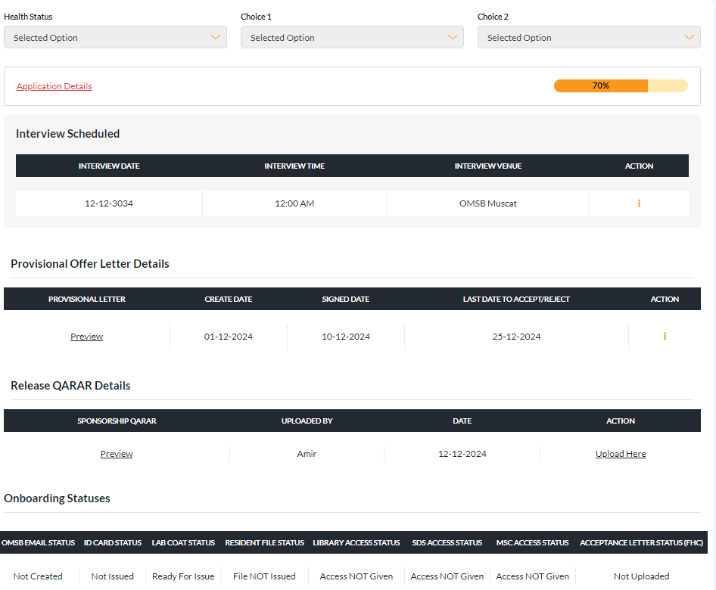

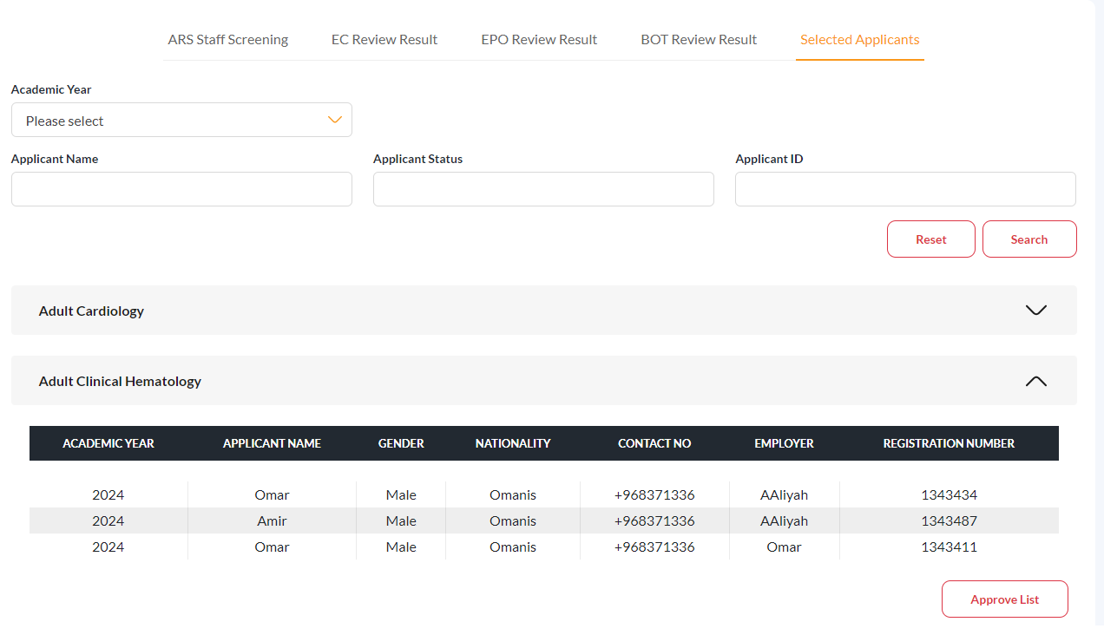

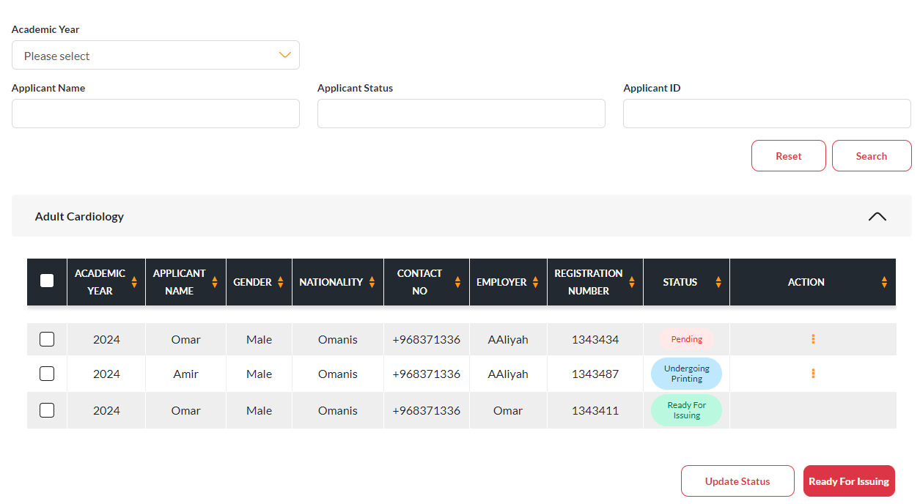

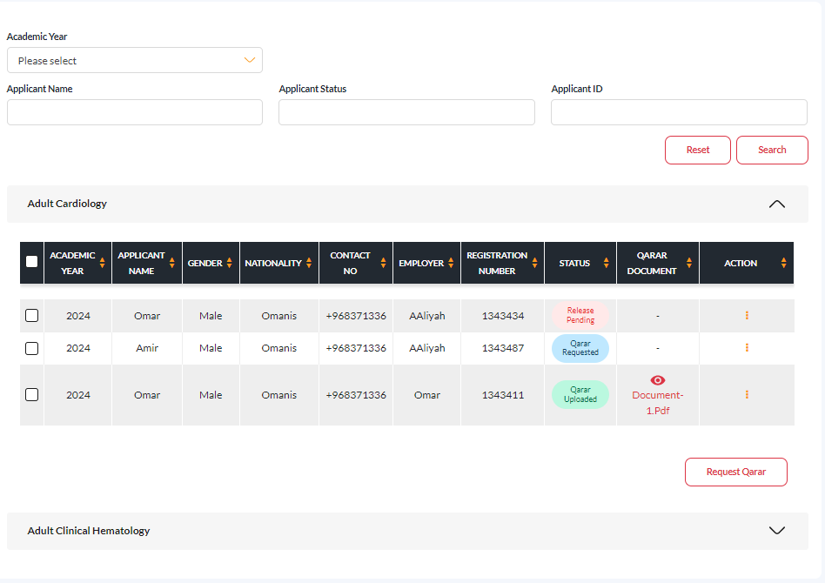

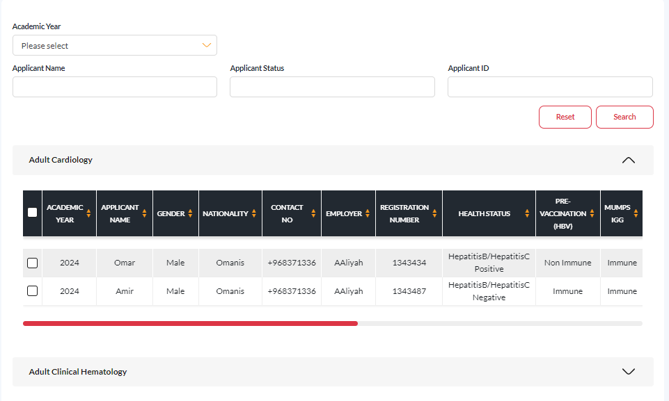

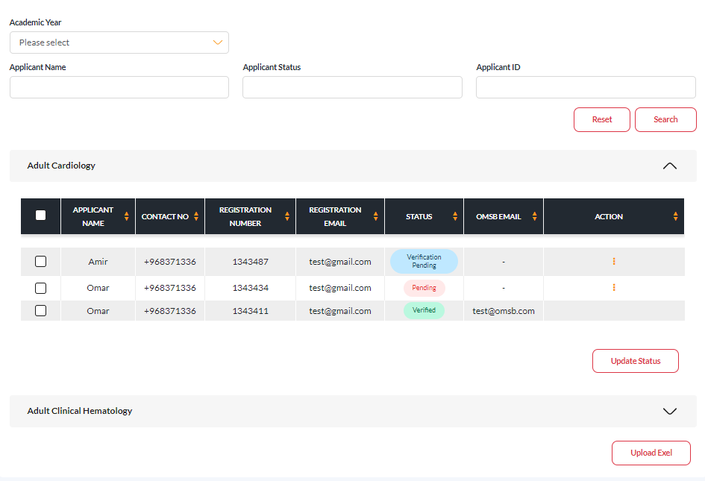

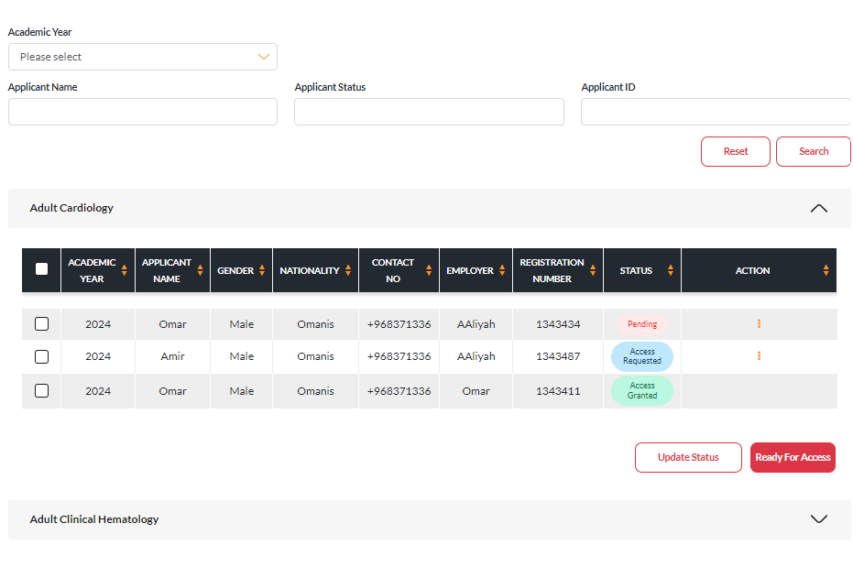

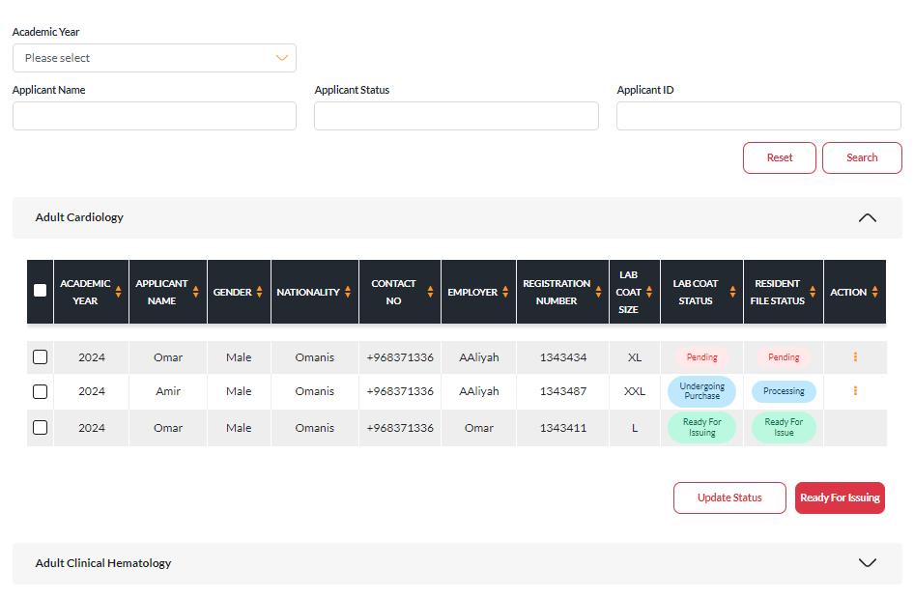

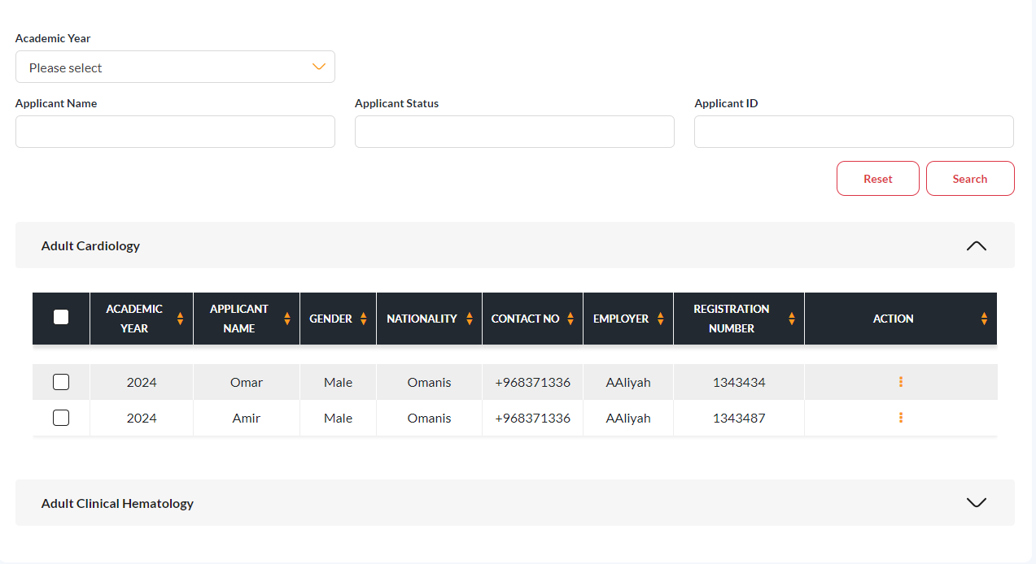

### **Business Logic**

1. The AR, DGHS, DGAA, EPO, ARS and BOT users will log in to the e-portal. Once logged in, they should be able to see the following navigation menus on the left-hand side (LHS):

a. Admission  
 b. Local Fellowship

1. The AR user will receive a list of applicants for the local fellowship, including those who are employed in the government sector but not in the Ministry of Health (MOH). These candidates will be listed as "Under Screening" status.
2. After that, the AR user can either approve or reject a candidate, providing a reason for any rejection. Approved candidates will be marked as "Shortlisted," while rejected candidates will be marked as "Rejected."

Table 1: Reject comments.

|  |  |  |  |  |
| --- | --- | --- | --- | --- |
| Field Name | Mandatory/Optional | Field Type | Multilingual Support | Comments |
| Reason For Rejection | Optional | Drop down | No |  |

1. Candidates who are employed in the government sector and in MOH require two approvals.
2. First, the DGHS user will decide to either approve or reject a candidate, providing a reason for any rejection. Approved candidates will be marked as "Shortlisted," while rejected candidates will be marked as "Rejected", Refer to Table 1 for the details of the rejection reason comment field.
3. The DGHS user will approve candidates by uploading the Employer Approved Application Form, which may include a digital signature or be submitted without one.

|  |  |  |  |  |
| --- | --- | --- | --- | --- |
| Field Name | Mandatory/Optional | Field Type | Multilingual Support | Comments |
| Employer Approved Application Form | Mandatory | File | No |  |
| Mobile Number | Mandatory | Numeric | No |  |

1. The DGAA user will receive the list of candidates approved by the DGHS user, marked as "Under Screening" in the DGAA list.
2. The DGAA user will then decide whether to approve or reject these candidates, providing a reason for any rejection. Approved candidates will be marked as "Shortlisted," while rejected candidates will be marked as "Rejected", Refer to Table 1 for the details of the rejection reason comment field.
3. The DGAA user also has the option to make bulk decisions by checking the boxes for multiple candidates.
4. The ARS user will receive a list of candidates who are unemployed and in the private sector. These candidates will directly land in the ARS staff screening tab, marked as "Under Screening."
5. Additionally, all candidates who have received employer approval will also be listed in the ARS staff screening tab. Candidates approved by the employer will be marked as "Under Screening," while those rejected by the employer will be marked as "Rejected by Employer."
6. The ARS user will approve or reject all candidates whose status is "Under Screening."
7. Once approved, the status will change to "Shortlisted."
8. The ARS user can also reject candidates, providing comments, and their status will change to "Rejected." Refer to Table 1 for the details of the rejection reason comment field.
9. Within the applicant details screen, the ARS user can provide review comments based on their assessment. There are six accordions, and for each accordion, the user can give specific comments.

|  |  |  |  |  |
| --- | --- | --- | --- | --- |
| Field Name | Mandatory/Optional | Field Type | Multilingual Support | Comments |
| Comment | Optional | Text Box | No |  |

1. The ARS user can send communication messages by checking the appropriate boxes for either email or SMS.

|  |  |  |  |  |
| --- | --- | --- | --- | --- |
| Field Name | Mandatory/Optional | Field Type | Multilingual Support | Comments |
| Communication Type | Mandatory | Check Box | No |  |
| Message | Mandatory | Text Box | No |  |

1. Once the ARS user has made decisions for all candidates, they will send the list of shortlisted candidates to the EC. At that time, the status for the ARS user will be "Under EC Review," while the status for the EC user will be "Shortlisted."
2. If an applicant applied for two choices, the applications will be sent to two ECs
3. The EC will receive a list of applications from the ARS. In that list, if the applicant’s choices belong to the logged EC’s related program, those candidates will be listed in the EC Review tab.
4. During the initial setup, if filtration exams and interviews are required, the EC will see buttons for these options in this tab.
5. If a filtration exam is required, the EC can schedule it with the fields mentioned below.

|  |  |  |  |  |
| --- | --- | --- | --- | --- |
| Field Name | Mandatory/Optional | Field Type | Multilingual Support | Comments |
| Exam Date | Mandatory | Date | No |  |
| Exam Time | Mandatory | Time | No |  |
| Exam Venue | Mandatory | Text Box | No |  |
| Comments | Optional | Text Box | No |  |

1. After the filtration exam, the EC will provide results as "Pass," "Fail," or "Absent." If "Fail" or "Absent" is indicated, those candidates' statuses will change to "Rejected.
2. The EC user will schedule interviews for all the candidates whose filtration exam status is 'Pass,' and they can also reschedule the interviews if necessary.
3. While scheduling or rescheduling, the system should check if the candidate already has another interview on the same date and time.

|  |  |  |  |  |
| --- | --- | --- | --- | --- |
| Field Name | Mandatory/Optional | Field Type | Multilingual Support | Comments |
| Interview Panel | Mandatory | Drop down | No |  |
| Time Required for Each Interview | Mandatory | Time | No |  |
| Break Between Interviews | Mandatory | Time | No |  |
| Lunch Start Time | Mandatory | Time | No |  |
| Lunch End Time | Mandatory | Time | No |  |
| Interview Schedule Dates | Mandatory | Date | No | This should be multiple date select field. |
| Interview Venue Address | Mandatory | Text Box | No |  |

1. In the Schedule Interview screen, the fields 'Total Number of Interviews Possible in One Day' and 'Total Number of Days Required' should be calculated based on the above given fields.
2. Additionally, the EC can reschedule the interview separately for a particular candidate using the fields below.

|  |  |  |  |  |
| --- | --- | --- | --- | --- |
| Field Name | Mandatory/Optional | Field Type | Multilingual Support | Comments |
| Interview Date | Mandatory | Date | No |  |
| Interview Time | Mandatory | Time | No |  |
| Interview Venue | Mandatory | Text Box | No |  |

1. After scheduling the interview, the EC user will raise a media request to announce that the interview is scheduled for the respective program, including the scheduled details.
2. The applicant will log in and can accept or reject the interview schedule date. If accepted, the status will be "Accepted"; if rejected, the status will be "Rejected," along with comments.
3. The interview will take place offline.
4. During the scheduling of interviews, the selected panels will have their members and chairpersons log in to evaluate the candidates' scores.
5. When a panel member logs in, they will receive a list of applications from candidates who accepted the interview, with the status displayed as "Scheduled" on the panel member’s screen.
6. The panel member will evaluate the candidate using a dynamic form builder and provide recommendations and rankings.
7. The panel chairman will log in and will receive the same list displayed for the panel members.
8. Afterward, the panel chairman will review all the panel members' scores and provide a summary report along with recommendations and comments.

|  |  |  |  |  |
| --- | --- | --- | --- | --- |
| Field Name | Mandatory/Optional | Field Type | Multilingual Support | Comments |
| Recommendation | Mandatory | Radio Button | No |  |
| Comments | Optional | Text box | No |  |

1. If the chairman gives recommendations as "Recommended," "Waitlisted," or "Not Recommended," the status will show as "Completed." If the recommendation is "No Show," then the status will be updated to "No Show".
2. After providing the summary report for all candidates, the chairman will submit the results to the EC. Any status changes made on the panel chairman's screen will also appear in the EC Review tab list table for EC user.
3. The EC will receive the panel chairman’s results, which will be listed in the EC Recommendation tab screen.
4. The names of the panels associated with the logged EC will be dynamically created as table headers in the EC Recommendation tab screen.
5. The EC will then give their final recommendations for the candidates.

|  |  |  |  |  |
| --- | --- | --- | --- | --- |
| Field Name | Mandatory/Optional | Field Type | Multilingual Support | Comments |
| Recommendation | Mandatory | Drop down | No |  |
| Comments | Optional | Text box | No |  |

1. Once the EC has provided recommendations for all candidates, they will submit the results to the ARS user. At that time, if a candidate's status is 'Completed,' it should change to 'EC Result Received' on the ARS staff screening tab. If the status is 'Rejected' or 'No Show,' those statuses should also appear on the ARS staff screening tab.
2. The ARS user will log in and see the EC results in the EC Review Result tab.
3. The applicant list should be organized in program accordions. Initially, the status of the program accordion will be "Interview Result Not Received." Once the result is received from the EC, the status should change to "Received".
4. Inside the accordion, there will be four lists: Recommended, Waitlist, Not Recommended, and No Show. Candidates should be moved to these lists based on their recommendations, and the lists should be sorted by rank.
5. The ARS user will update the reason for absence for no-show candidates.

|  |  |  |  |  |
| --- | --- | --- | --- | --- |
| Field Name | Mandatory/Optional | Field Type | Multilingual Support | Comments |
| Absent Type | Optional | Drop down | No |  |

1. After that, the ARS user will create a consolidated list for the EPO. While creating this list, the system should check if a candidate has recommended two programs. If so, we need to determine which is Choice 1 and use that for the recommended list, while the other should be moved to the waitlist. We must avoid including candidates from the Not Recommended and No-Show lists when sending to the EPO."
2. While sending the consolidated list to the EPO, the status of Recommended and Waitlisted candidates should be set to 'Under EPO Review,' while Not Recommended candidates should be marked as 'Rejected' in the ARS staff screening tab.
3. After the offline EB meetings, the EPO user will log in to receive the consolidated list from the ARS user. The EPO user will change the rank of each candidate based on the EB meetings if required and may swap applications between the Recommended and Waitlist lists.
4. When swapping, the ranks must also be adjusted accordingly.
5. Additionally, the EPO can reject recommended candidates, providing rejection comments. These candidates should be moved to the Rejected list. Refer to Table 1 for the details of the rejection reason comment field.
6. After completing the review, the EPO user will submit the results to the ARS user. At that time, the status of the candidates will change to "EPO Result Received" on the ARS staff screening tab.
7. The ARS user will log in and see the EPO results in the EPO Review Result tab.
8. Here, the results will also be displayed as program accordions, with three lists: Recommended, Waitlist, and Rejected.
9. The ARS user will create a consolidated list for the BOT, avoiding the rejected candidate list.
10. While sending the consolidated list to the BOT, the status of Recommended and Waitlisted candidates should change to "Under BOT Review," and the status of Rejected candidates should change to "Rejected" in the ARS staff screening tab.
11. After logging in, the BOT will perform the same actions as the EPO and then send his results to the ARS user. At that time, the status of the candidates will be "BOT Result Received" in the ARS staff screening tab.
12. The ARS user will log in and see the BOT results in the BOT Review Result tab.
13. Here, the results will also be organized as program accordions. The ARS user will then generate an offer letter for recommended candidates. The offer letter status should be "Offer Letter Created".
14. For generating the offer letter, web content will be used.
15. The ARS user will send the generated offer letter to the EPO for a digital signature. When sending, the ARS user should provide the last date for accepting the offer letter. The offer letter status should be "Sent to EPO".

|  |  |  |  |  |
| --- | --- | --- | --- | --- |
| Field Name | Mandatory/Optional | Field Type | Multilingual Support | Comments |
| Last date for accepting the offer letter | Mandatory | Date | No |  |

1. The EPO will log in and sign each document using integration, then send it to the applicant. The offer letter status should be "Sent to Applicant".
2. The applicant will log in; if they approve the offer letter using the document, the status should change to 'Approved by Applicant,' and the system should create an OMSB registration number in the format (F for Local Fellowship and 24 for the year, starting from 001). For example, F24001. This list will be displayed in the Selected Applicants tab.

|  |  |  |  |  |
| --- | --- | --- | --- | --- |
| Field Name | Mandatory/Optional | Field Type | Multilingual Support | Comments |
| Document Name | Optional | Text Box | No |  |
| Document | Optional | File |  |  |

1. If the applicant rejects the offer letter, the system should check if there are any candidates in the waitlist. If so, the top candidate should be moved to the recommended list, and the rank should be adjusted accordingly. The same process will be repeated.
2. Even if they do not accept the offer letter by the deadline, the same rejection process will occur using the scheduler.
3. After all applicants have accepted the offer letter, the ARS user will approve the list in the Selected Applicants tab. At that time, the status should change to "Provisionally Selected by OMSB," and all other candidates' statuses should change to "Rejected".
4. Different departments will receive the approved candidate list for the onboarding process.
5. The Administrative Affairs Section staff will log in and see the approved candidate list with a status of 'Pending.' They will then update the ID card status and can perform bulk updates by checking multiple checkboxes.

|  |  |  |  |  |
| --- | --- | --- | --- | --- |
| Field Name | Mandatory/Optional | Field Type | Multilingual Support | Comments |
| ID Card Status | Mandatory | Drop down | No |  |

1. The Trainee Affairs Follow-Up Section staff (Follow-up Health Care Committee, FHC) will log in and see the approved candidate list along with health status and vaccination details. If any health status is positive or vaccination status is immune, they can download the AHA form.
2. The IT Department staff will log in and see the approved candidate list with a status of "Pending." They will create an OMSB email ID and update the email ID status and can perform bulk updates by checking multiple checkboxes and they can upload an Excel file to update the email ID status.

|  |  |  |  |  |
| --- | --- | --- | --- | --- |
| Field Name | Mandatory/Optional | Field Type | Multilingual Support | Comments |
| Email ID Status | Mandatory | Drop down | No |  |
| OMSB Email Id | Mandatory | Text Box | No |  |

1. The Medical Library Section staff (E-Library) will log in and see the approved candidate list with a status of "Pending." They will then update the library access status and can perform bulk updates by checking multiple checkboxes.

|  |  |  |  |  |
| --- | --- | --- | --- | --- |
| Field Name | Mandatory/Optional | Field Type | Multilingual Support | Comments |
| E-Library Access | Mandatory | Drop down | No |  |

1. The Simulation Program Section staff (Medical Simulation Centre) will log in and see the approved candidate list with a status of "Pending." They will update the MSC status and can perform bulk updates by checking multiple checkboxes.

|  |  |  |  |  |
| --- | --- | --- | --- | --- |
| Field Name | Mandatory/Optional | Field Type | Multilingual Support | Comments |
| Medical Simulation Centre Access | Mandatory | Drop down | No |  |

1. The Purchasing and Contracts Section staff will log in and see the approved candidate list with lab coat and resident status as "Pending." They will then update the lab coat and resident file status and can perform bulk updates by checking multiple checkboxes.

|  |  |  |  |  |
| --- | --- | --- | --- | --- |
| Field Name | Mandatory/Optional | Field Type | Multilingual Support | Comments |
| Lab Coat Status | Mandatory | Drop down | No |  |
| Resident File Status | Mandatory | Drop down | No |  |

1. The Skill Development Section staff will log in and see the approved candidate list with a status of "Pending." They will update the access to Skill Development workshops status and can perform bulk updates by checking multiple checkboxes.

|  |  |  |  |  |
| --- | --- | --- | --- | --- |
| Field Name | Mandatory/Optional | Field Type | Multilingual Support | Comments |
| Skill Development Access | Mandatory | Drop down | No |  |

1. The EPO will log in and see the approved candidate list with a status of "Pending." After that, they will request Qarar, along with the Last Date for uploading Qarar, the status should change to "Qarar Requested".

|  |  |  |  |  |
| --- | --- | --- | --- | --- |
| Field Name | Mandatory/Optional | Field Type | Multilingual Support | Comments |
| Last Date for Qarar Approval | Mandatory | Date | No |  |
| Upload Document | Mandatory | File | No |  |

1. After Qarar requested then three members can upload the Qarar: the EPO, the applicant, and the employer. After uploading, the status will change to "Qarar Uploaded".
2. The EPO will then digitally sign the Qarar through integration, and the status will change to "E-Signed".

|  |  |  |  |  |
| --- | --- | --- | --- | --- |
| Field Name | Mandatory/Optional | Field Type | Multilingual Support | Comments |
| Phone Number | Mandatory | Numeric | No |  |

1. In all screens, a search functionality should be implemented using the following fields:

|  |  |  |  |  |
| --- | --- | --- | --- | --- |
| Field Name | Mandatory/Optional | Field Type | Multilingual Support | Comments |
| Academic Year | Optional | Drop down | No |  |
| Applicant Name | Optional | Text Box | No |  |
| Applicant Status | Optional | Drop down | No |  |
| Applicant ID | Optional | Numeric | No |  |

### Notifications & Email template

The following email and notification content should be used when sending emails & notifications

|  |  |  |  |  |
| --- | --- | --- | --- | --- |
| **Scenario** | **Notification** | **Notification Action** | **Email** | **Email Action** |
| **When AR or DGAA Employer Approving the applicant by clicking on the approve button.** | Greetings [$REQUESTER_NAME$], The following applicants have been Approved by the employer, [$APPLICANT_NAMES$] | When clicked on notification The ARS User will be redirected to ARS screening tab. | Dear [$REQUESTER_NAME$],  The following applicants have been Approved by the employer:  [$APPLICANT_NAMES$]  Click here for more details.  Best Regards,  Oman Medical Speciality Board. | When clicked on email link The ARS User will be redirected to ARS screening tab. |
| **When DGHS Employer Approving the applicant by clicking on the approve with digital signature or approve without digital signature button.** | Greetings [$REQUESTER_NAME$], The applicant, [$APPLICANT_NAME$], has been Approved by the employer. | When clicked on notification T The DGAA User will be redirected to DGAA user listing page. | Dear [$REQUESTER_NAME$],  The applicant, [$APPLICANT_NAME$], has been Approved by the employer. Click here for more details.  Best Regards,  Oman Medical Speciality Board. | When clicked on email link The DGAA User will be redirected to DGAA user listing page. |
| **When Employer Rejecting the applicant by clicking on the reject button.** | Greetings [$REQUESTER_NAME$], The following applicants have been Rejected by the employer, [$APPLICANT_NAMES$] | When clicked on notification The ARS User will be redirected to ARS screening tab. | Dear [$REQUESTER_NAME$],  The following applicants have been Rejected by the employer:  [$APPLICANT_NAMES$]  Click here for more details.  Best Regards,  Oman Medical Speciality Board. | When clicked on email link The User will be redirected to E-portal.  When clicked on email link The ARS User will be redirected to ARS screening tab. |
|  | Greetings [$REQUESTER_NAME$], The applicant, [$APPLICANT_NAME$], has been rejected by the employer. | When clicked on notification The Applicant will be redirected to application details page. | Dear [$REQUESTER_NAME$],  We are pleased to inform you that you have been added to the employer approver list. Click here.  Best Regards,  Oman Medical Speciality Board. | When clicked on email link The Applicant will be redirected to application details page. |
| **When ARS user sending communication message by clicking on send button** | N/A | N/A | Dear [$REQUESTER_NAME$],  [$MESSAGE$].  Best Regards,  Oman Medical Speciality Board. | N/A |
| **When ARS User Submitting shortlisted candidate to EC by clicking on the Send to EC button.** | Greetings [$REQUESTER_NAME$], We have forwarded the approved candidates, please proceed with further processing. | When clicked on notification The EC User will be redirected to EC Review tab. | Dear [$REQUESTER_NAME$],  We have forwarded the approved candidates, please proceed with further processing. Click here.  Best Regards,  Oman Medical Speciality Board. | When clicked on email link The EC User will be redirected to EC Review tab. |
| **When EC User Scheduling the interview by clicking on the schedule interview button.** | Greetings [$REQUESTER_NAME$], The interview for the [$PROGRAM_NAME$] program was scheduled for Date:[$DATE$], Time:[$TIME$]. | When clicked on notification The Applicant will be redirected to application details page. | Dear [$REQUESTER_NAME$],  The interview for the [$PROGRAM_NAME$] program was scheduled for Date:[$DATE$], Time:[$TIME$]. Click here for more details.  Best regards,  Oman Medical Specialty Board | When clicked on email link The Applicant will be redirected to application details page. |
| **When Panel chairman submitting the result to EC by clicking on the submit result button.** | Greetings [$REQUESTER_NAME$], The panel chairman has submitted the results. | When clicked on notification The EC User will be redirected to EC Recommendation tab. | Dear [$REQUESTER_NAME$],  The panel chairman has submitted the results. Click here for more details.  Best regards,  Oman Medical Specialty Board | When clicked on email link The EC User will be redirected to EC Recommendation tab. |
| **When EC User Submitting recommendation to ARS staff by clicking on the submit result button.** | Greetings [$REQUESTER_NAME$], The [$PROGRAM_NAME$] has received the EC Recommendation. | When clicked on notification The ARS User will be redirected to EC Review Result  tab. | Dear [$REQUESTER_NAME$],  The [$PROGRAM_NAME$] has received the EC Recommendation. Click here for more details.  Best regards,  Oman Medical Specialty Board | When clicked on email link The ARS User will be redirected to EC Review Result  tab. |
| **When ARS User submitting consolidated list to EPO by clicking on submit button** | Greetings [$REQUESTER_NAME$], ARS User has submitted the EC review results. | When clicked on notification The EPO User will be redirected to EB Meeting Review tab. | Dear [$REQUESTER_NAME$],  ARS User has submitted the EC review results. Click here for more details.  Best regards,  Oman Medical Specialty Board | When clicked on email link The EPO User will be redirected to EB Meeting Review tab. |
| **When EPO User Submitting the result to ARS staff by clicking on the submit button.** | Greetings [$REQUESTER_NAME$], The EPO has submitted the results. | When clicked on notification The ARS User will be redirected to EPO Review Result  tab. | Dear [$REQUESTER_NAME$],  The EPO has submitted the results. Click here for more details.  Best regards,  Oman Medical Specialty Board | When clicked on email link The ARS User will be redirected to EPO Review Result  tab. |
| **When ARS User submitting consolidated list to BOT by clicking on submit button** | Greetings [$REQUESTER_NAME$], ARS User has submitted the EPO review results. | When clicked on notification The BOT User will be redirected to BOT Listing page. | Dear [$REQUESTER_NAME$],  ARS User has submitted the EPO review results. Click here for more details.  Best regards,  Oman Medical Specialty Board | When clicked on email link The BOT User will be redirected to BOT Listing page. |
| **When BOT User Submitting the result to ARS staff by clicking on the submit button.** | Greetings [$REQUESTER_NAME$], The BOT has submitted the results. | When clicked on notification The ARS User will be redirected to BOT Review Result  tab. | Dear [$REQUESTER_NAME$],  The BOT has submitted the results. Click here for more details.  Best regards,  Oman Medical Specialty Board | When clicked on email link The ARS User will be redirected to BOT Review Result  tab. |
| **When ARS staff sending generated offer letter to EPO for E-sign by clicking on the Send Provisional Offer Letter to EPO button.** | Greetings [$REQUESTER_NAME$], You have received an offer letter from BOT for digital signature. | When clicked on notification The EPO will be redirected to Offer Letter Digital Signature tab. | Dear [$REQUESTER_NAME$],  You have received an offer letter from BOT for digital signature. Click here for more details.  Best regards,  Oman Medical Specialty Board | When clicked on email link The EPO User will be redirected to Offer Letter Digital Signature  tab. |
| **When EPO Sending signed offer letter to Applicant by clicking on the Send Signed Offer Letter button.** | Greetings [$REQUESTER_NAME$], Congratulations! You have been selected for the [$PROGRAM_NAME$] program. | When clicked on notification The Applicant will be redirected to application details page. | Dear [$REQUESTER_NAME$],  Congratulations! You have been selected for the [$PROGRAM_NAME$] program. Please find the attached Offer Letter. For more information, click here.  Best regards,  Oman Medical Specialty Board | When clicked on email link The Applicant will be redirected to application details page. |
| **When applicant accept the offer letter by clicking on Accept button.** | Greetings [$REQUESTER_NAME$], The offer letter has been accepted by the applicant. | When clicked on notification The ARS User will be redirected to BOT Review Result  tab. | Dear [$REQUESTER_NAME$],  The offer letter has been accepted by the applicant. Click here for more details.  Best regards,  Oman Medical Specialty Board | When clicked on email link The ARS User will be redirected to BOT Review Result  tab. |
| **When applicant reject the offer letter by clicking on Reject button.** | Greetings [$REQUESTER_NAME$], The offer letter has been Rejected by the applicant. | When clicked on notification The ARS User will be redirected to BOT Review Result  tab. | Dear [$REQUESTER_NAME$],  The offer letter has been Rejected by the applicant. Click here for more details.  Best regards,  Oman Medical Specialty Board | When clicked on email link The ARS User will be redirected to BOT Review Result  tab. |
| **When ARS user approving the selected candidate by clicking on the Approve list button** | Greetings [$REQUESTER_NAME$], The OMSB has officially selected you for [$PROGRAM_NAME$] program. | When clicked on notification The Applicant will be redirected to application details page. | Dear [$REQUESTER_NAME$],  The OMSB has officially selected you for [$PROGRAM_NAME$] program. Click here for more details.  Best regards,  Oman Medical Specialty Board | When clicked on email link The Applicant will be redirected to application details page. |
|  | Greetings [$REQUESTER_NAME$], We are pleased to inform you that a candidate has been officially approved by the ARS staff. Please proceed with the necessary steps to finalize the process. | When clicked on notification The department user will be redirected to their respective listing page. | Dear [$REQUESTER_NAME$],  We are pleased to inform you that a candidate has been officially approved by the ARS staff. Please proceed with the necessary steps to finalize the process. For more details Click here.  Best regards,  Oman Medical Specialty Board | When clicked on email link The department will be redirected to their respective listing page. |
| **When ARS user rejecting the not selected candidate by clicking on the Approve list button** | Greetings [$REQUESTER_NAME$], We regret to inform you that you were not selected. | When clicked on notification The Applicant will be redirected to application details page. | Dear [$REQUESTER_NAME$],  We regret to inform you that you were not selected. Click here for more details.  Best regards,  Oman Medical Specialty Board | When clicked on email link The Applicant will be redirected to application details page. |
| **When Administrative Affairs Section staff updating the Id card status by clicking on the update Status or ready to issue button.** | Greetings [$REQUESTER_NAME$], We are pleased to inform you that your ID card has been processed and is now ready for issuance. | When clicked on notification The Applicant will be redirected to application details page. | Dear [$REQUESTER_NAME$],  We are pleased to inform you that your ID card has been processed and is now ready for issuance. For more details Click here.  Best regards,  Oman Medical Specialty Board | When clicked on email link The Applicant will be redirected to application details page. |
|  | Greetings [$REQUESTER_NAME$], The ID card for [$CANDIDATE_NAME$] has been processed and is now ready for issue. | When clicked on notification The ARS User will be redirected to ARS screening tab. | Dear [$REQUESTER_NAME$],  The ID card for [$CANDIDATE_NAME$] has been processed and is now ready for issue. For more details Click here.  Best regards,  Oman Medical Specialty Board | When clicked on email link The ARS User will be redirected to ARS screening tab. |
| **When EPO user requesting a qarar by clicking on the request qarar button.** | Greetings [$REQUESTER_NAME$], The requester has requested the Qarar. Please upload the Qarar. | When clicked on notification The Applicant will be redirected to application details page. | Dear [$REQUESTER_NAME$],  The requester has requested the Qarar. Please upload the Qarar. For more details Click here.  Best regards,  Oman Medical Specialty Board | When clicked on email link The Applicant will be redirected to application details page. |
| **When EPO user uploading a qarar by clicking on the upload qarar button.** | Greetings [$REQUESTER_NAME$], The Qarar has been uploaded. | When clicked on notification The Applicant will be redirected to application details page. | Dear [$REQUESTER_NAME$],  The Qarar has been uploaded. For more details Click here.  Best regards,  Oman Medical Specialty Board | When clicked on email link The Applicant will be redirected to application details page. |
|  | Greetings [$REQUESTER_NAME$], The Qarar document for [$CANDIDATE_NAME$] has been successfully uploaded. | When clicked on notification The ARS User will be redirected application details page. | Dear [$REQUESTER_NAME$],  The Qarar document for [$CANDIDATE_NAME$] has been successfully uploaded. For more details Click here.  Best regards,  Oman Medical Specialty Board | When clicked on email link The ARS User will be redirected to application details page. |
| **When Medical Library Section staff updating the library access status by clicking on the update Status or ready to access button.** | Greetings [$REQUESTER_NAME$], We are pleased to inform you that your E-Library access has been granted. | When clicked on notification The Applicant will be redirected to application details page. | Dear [$REQUESTER_NAME$],  We are pleased to inform you that your E-Library access has been granted. For more details Click here.  Best regards,  Oman Medical Specialty Board | When clicked on email link The Applicant will be redirected to application details page. |
|  | Greetings [$REQUESTER_NAME$], The E-Library Access for [$CANDIDATE_NAME$] has been Granted. | When clicked on notification The ARS User will be redirected to ARS screening tab. | Dear [$REQUESTER_NAME$],  The E-Library Access for [$CANDIDATE_NAME$] has been Granted. For more details Click here.  Best regards,  Oman Medical Specialty Board | When clicked on email link The ARS User will be redirected to ARS screening tab. |
| **When**  **Simulation Program Section staff**  **Updating the MSC access status by clicking on the update Status or ready to access button.** | Greetings [$REQUESTER_NAME$], We are pleased to inform you that your Medical Simulation access has been granted. | When clicked on notification The Applicant will be redirected to application details page. | Dear [$REQUESTER_NAME$],  We are pleased to inform you that your Medical Simulation access has been granted. For more details Click here.  Best regards,  Oman Medical Specialty Board | When clicked on email link The Applicant will be redirected to application details page. |
|  | Greetings [$REQUESTER_NAME$], The Medical Simulation Access for [$CANDIDATE_NAME$] has been Granted. | When clicked on notification The ARS User will be redirected to ARS screening tab. | Dear [$REQUESTER_NAME$],  The Medical Simulation Access for [$CANDIDATE_NAME$] has been Granted. For more details Click here.  Best regards,  Oman Medical Specialty Board | When clicked on email link The ARS User will be redirected to ARS screening tab. |
| **When**  **Skill Development Section staff updating**  **Skill development workshop status by clicking on the update Status or ready to access button.** | Greetings [$REQUESTER_NAME$], We are pleased to inform you that your Skill Development Workshop access has been granted. | When clicked on notification The Applicant will be redirected to application details page. | Dear [$REQUESTER_NAME$],  We are pleased to inform you that your Skill Development Workshop access has been granted. For more details Click here.  Best regards,  Oman Medical Specialty Board | When clicked on email link The Applicant will be redirected to application details page. |
|  | Greetings [$REQUESTER_NAME$], The Skill development workshops Access for [$CANDIDATE_NAME$] has been Granted. | When clicked on notification The ARS User will be redirected to ARS screening tab. | Dear [$REQUESTER_NAME$],  The Skill development workshops Access for [$CANDIDATE_NAME$] has been Granted. For more details Click here.  Best regards,  Oman Medical Specialty Board | When clicked on email link The ARS User will be redirected to ARS screening tab. |
| **When**  **Purchasing and contract Section staff updating the**  **Lab coat and resident file status by clicking on the update Status or ready to issue button.** | Greetings [$REQUESTER_NAME$], We are pleased to inform you that your Lab Coat has been processed and is now ready for issuance. | When clicked on notification The Applicant will be redirected to application details page. | Dear [$REQUESTER_NAME$],  We are pleased to inform you that your Lab Coat has been processed and is now ready for issuance. For more details Click here.  Best regards,  Oman Medical Specialty Board | When clicked on email link The Applicant will be redirected to application details page. |
|  | Greetings [$REQUESTER_NAME$], The Lab Coat for [$CANDIDATE_NAME$] has been processed and is now ready for issue. | When clicked on notification The ARS User will be redirected to ARS screening tab. | Dear [$REQUESTER_NAME$],  The Lab Coat for [$CANDIDATE_NAME$] has been processed and is now ready for issue. For more details Click here.  Best regards,  Oman Medical Specialty Board | When clicked on email link The ARS User will be redirected to ARS screening tab. |
|  | Greetings [$REQUESTER_NAME$], We are pleased to inform you that your Resident File has been processed and is now ready for issuance. | When clicked on notification The Applicant will be redirected to application details page. | Dear [$REQUESTER_NAME$],  We are pleased to inform you that your Resident File has been processed and is now ready for issuance. For more details Click here.  Best regards,  Oman Medical Specialty Board | When clicked on email link The Applicant will be redirected to application details page. |
|  | Greetings [$REQUESTER_NAME$], The Resident File for [$CANDIDATE_NAME$] has been processed and is now ready for issue. | When clicked on notification The ARS User will be redirected to ARS screening tab. | Dear [$REQUESTER_NAME$],  The Resident File for [$CANDIDATE_NAME$] has been processed and is now ready for issue. For more details Click here.  Best regards,  Oman Medical Specialty Board | When clicked on email link The ARS User will be redirected to ARS screening tab. |

# Liferay Design Components

|  |  |  |  |
| --- | --- | --- | --- |
| **Liferay Page Name** |  | **Page Type** | Private |
|  |
| **Layout Name** | Custom: 1 Column | **Layout Type** | 100 |
|  |  |  |  |
|  | omsb-common-api | The API module will be responsible for creating contracts(interfaces) that will be used across all the web modules to access the APIs’. All the model classes responsible for request & response of the Http Connections should reside in this module. The common constants too should be part of this module. | |
| omsb-common-service | The service module will be responsible for implementing the contracts that are defined in the omsb-common-api | |
|  | omsb-admission | Service builder for ARS Setup Module. All the tables should be prefixed with namespace as “ars” | |
|  | omsb-form-builder | This module should be included to take the advantage of existing form builder module | |
|  | omsb-media-appeal | Service builder for Media Files request as this will be used at many places. All the tables should be prefixed with namespace as “ma” | |
|  | omsb-ars-screening-web | This module manages the screening process for applicants | |
| **Java Script Plugin Details** | JavaScript/jQuery | Used for implementing the dynamic generation of the html elements | |

# ER Diagram

[[Database-Design.xlsx](https://imtac.sharepoint.com/:x:/r/sites/omsb-aims/Shared%20Documents/1.OMSB%20Engineering/3-Development/Phase-2/Design/MSIC/Database-Design.xlsx?d=wb9758adc7c3d4fb284fb65bcad263f8d&csf=1&web=1&e=bM5Hgv)](https://imtac.sharepoint.com/:x:/r/sites/omsb-aims/_layouts/15/Doc.aspx?sourcedoc=%7B51F6197A-2144-4BE9-9F69-32ACB4B32456%7D&file=Database%20Design(ARS%20&%20SAS).xlsx=&action=default&mobileredirect=true)

# Appendix A: Document Control

## Revision History

|  |  |  |  |
| --- | --- | --- | --- |
| **Version** | **Date** | **Amended By** | **Reason for Change** |
| **1.0** | 08/11/2023 | Ravi Shah | Initial Draft |

Table 7: Revision History